SESSION 2 - POSTMAN API ASSIGNMENT
Completed Practical Submission
1. Postman Collection
A Postman collection was created to organize API requests. The collection contains authentication and user-related API requests, including GET, POST and PUT operations.
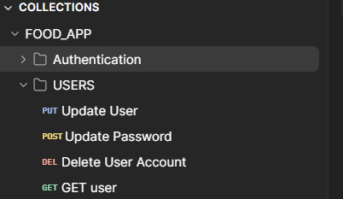
Figure 1: Postman collection and saved API requests
2. GET Request Testing
A GET request was tested in Postman. The request returned HTTP status 200 OK and a JSON response body, confirming that the API request was successful.
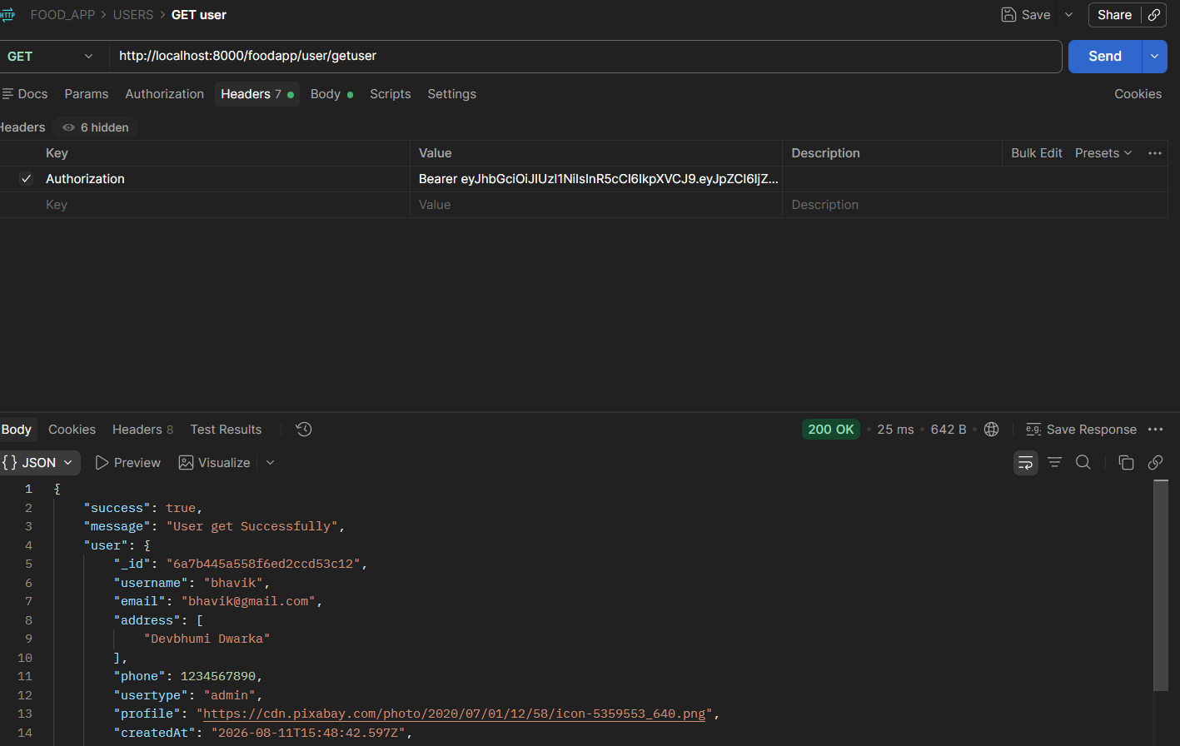
Figure 2: GET request with 200 OK response and JSON body
3. POST Request Testing
A POST request was tested by sending JSON data in the request body. The API returned 200 OK with a successful response, demonstrating that POST data was accepted and processed.
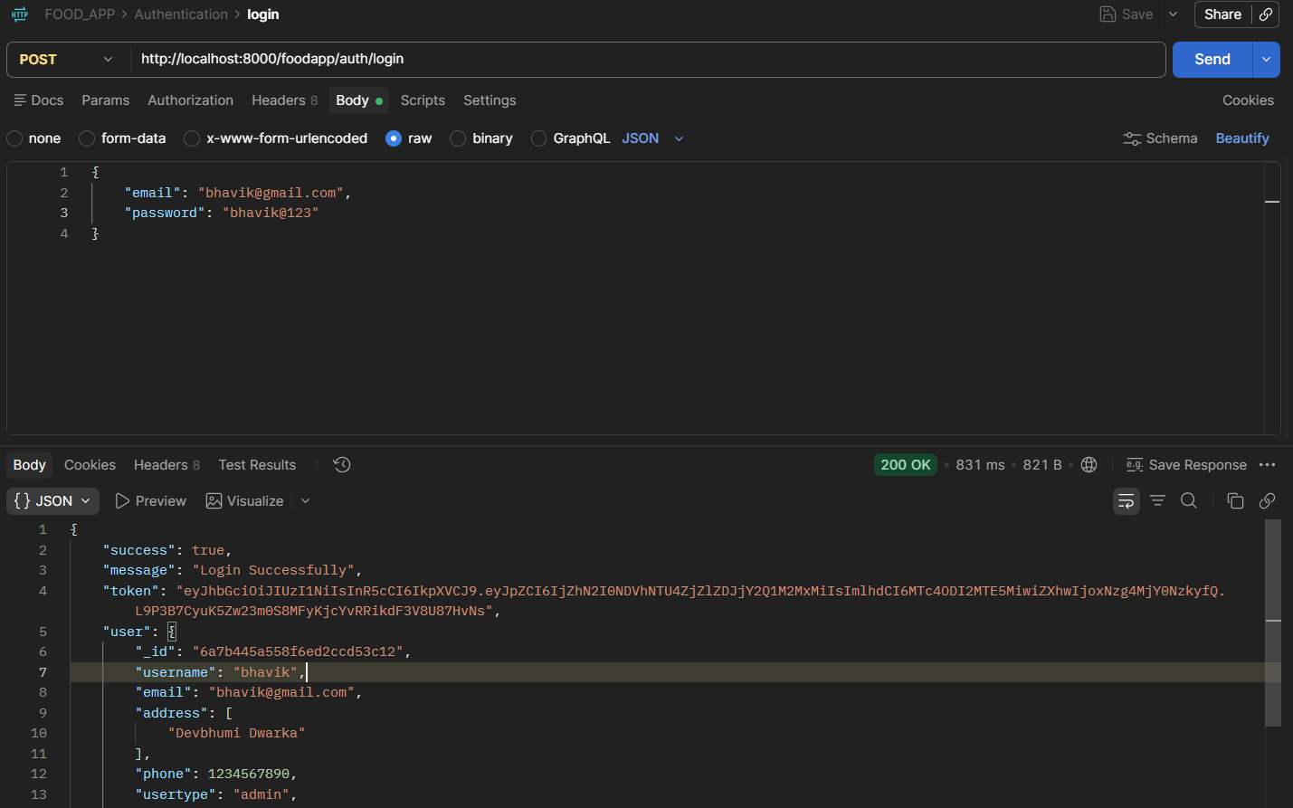
Figure 3: POST request with JSON body and successful response
4. Multiple Requests Saved and PUT Request Tested
Multiple API requests were saved in the Postman collection. A PUT request was also tested to update user information. The request returned 200 OK and the response shows the updated user data.
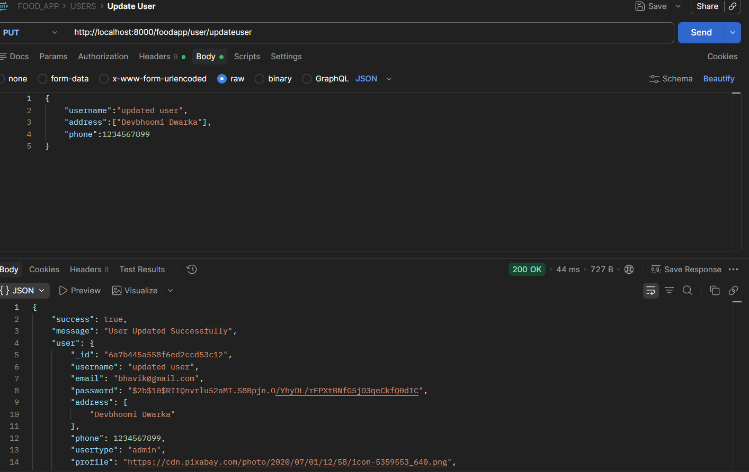
Figure 4: PUT request used to update user information
5. Exporting the Postman Collection
The Postman collection was opened using the Export collection option. The collection can be exported as a JSON file and shared with a classmate for peer review.
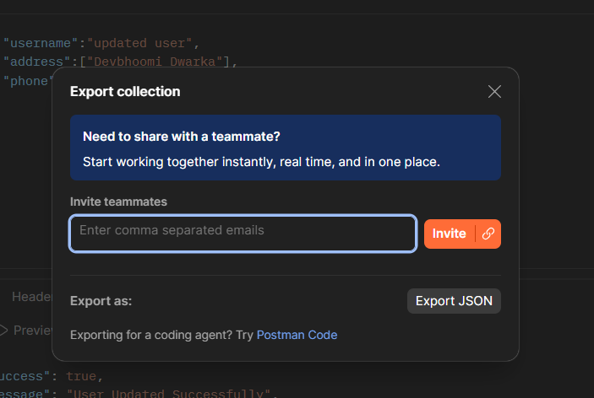
Figure 5: Postman Export Collection dialog
Conclusion
The Postman practical assignment was completed successfully. API requests were organized in a collection, GET, POST and PUT operations were tested, successful responses were verified, and the collection was prepared for export as a JSON file.

